**Problem 12.1**

The given algorithm is not correct as the following counterexample will demonstrate:

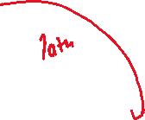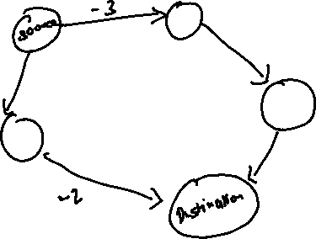

With the negative weights, path 1 with the total weight of 1 is the shortest path from the source to the destination. Path2 which has the total weight of 3 is not the solution.

Now, adding 3 to the weights of all the edges to make them positive, we get the following graph:

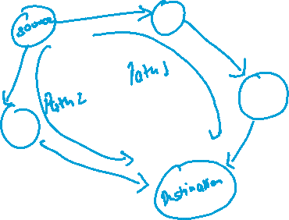

Now, Path 2 is the perceived to be the shortest path to the destination from the source with the total weight of 9, and the original and correct solution i.e. Path 1 is not produced since its weight 10 is more than that of path 2. Thus, adding a number to the negative weights of edges and implementing the Dijkstra’s algorithm does not produce the correct solution.

**Problem 12.3**

**Ans a.**

In this problem, the nodes are the individual squares on the grid, whilst the edges are the valid moves from an individual node. We can solve this problem by finding the shortest path (if there exists any) by trying to find the shortest path between the bottom right corner of the board to the upper left corner of the board. We can simply count the number of edges in the path to obtain the minimum number of moves to complete the game.